Meeting with Your Legislator

Tips for a Successful Meeting

The Hook, Line & Sinker is designed to guide you in preparing your presentation to a state or federal senator, representative/delegate and/or legislative staffer.

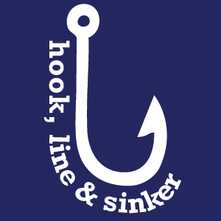
The Hook is part of your introduction and should draw your audience in. During the Hook, each person in the group presents who they are and a personal (but relevant) detail about themselves.

The Line draws your audience further in and offers less fact and more of a personal approach. At this time one or two people will share a personal story related to the meeting.

The Sinker is your “ask”, where one individual from your group will ask the Legislator or staffer for support of the issue. Ending with an “ask” is an essential way to close your meeting.

Example of the Hook, Line & Sinker for a step therapy ask:

Hook: My name is Sarah and I am a constituent of yours. I am 23 years old and was diagnosed with psoriatic arthritis when I was 15 years old.

Line, general: Each day, patients and providers face the reality of barriers to health care that impact treatment, health, and well-being. When these policies interfere with the patient-doctor relationship, they can result in delayed treatment, increased disease activity, loss of function, and potentially irreversible disease progression.

Line, personal For many patients, step therapy can create significant
approach: barriers to quality patient care, which can delay treatment and contribute to negative patient outcomes. I personally [insert story about yourself or someone you know that has experienced delays in care because of step therapy].

Sinker: Can we count on you to support step therapy reform? (mention specific bill number, sponsors, and key supporters)

